1. Retail Chain — Daily Sales Trend (2 Years)

Code
# Task 1: Retail chain daily sales - 2 year time series
# ------------------------------------------------------

set.seed(101)

n_days <- 730 # 2 years of daily data
dates <- seq(as.Date("2024-01-01"), by = "day", length.out = n_days)

t <- 1:n_days
trend <- 20000 + 15 * t # gentle long-term upward trend
weekly <- 3000 * sin(2 * pi * t / 7) # weekly (weekday/weekend) pattern
yearly <- 6000 * sin(2 * pi * t / 365.25 - 1.4) # holiday-season yearly pattern
noise <- rnorm(n_days, mean = 0, sd = 1800)

sales <- trend + weekly + yearly + noise
sales <- pmax(sales, 0)

daily_sales <- data.frame(date = dates, sales = sales)

# Fit a simple linear trend to quantify the long-term direction
fit <- lm(sales ~ t, data = daily_sales)
slope <- coef(fit)[2]

png("imgs/task1_retail_sales.png", width = 1000, height = 600, res = 120)
plot(daily_sales$date, daily_sales$sales, type = "l", col = "steelblue",
xlab = "Date", ylab = "Daily Sales (USD)",
main = "Retail Chain: Daily Sales Over the Past 2 Years")
abline(fit, col = "firebrick", lwd = 2, lty = 2)
legend("topleft", legend = c("Daily sales", "Linear trend"),
col = c("steelblue", "firebrick"), lty = c(1, 2), lwd = c(1, 2), bty = "n")
dev.off()

cat(sprintf("Linear trend slope: %.2f USD/day (~ %.0f USD/year)\n", slope, slope * 365))
cat(sprintf("Total change over 2 years (fitted): %.0f USD\n", slope * n_days))
cat(sprintf("Mean daily sales: %.0f USD | SD: %.0f USD\n", mean(sales), sd(sales)))

Output
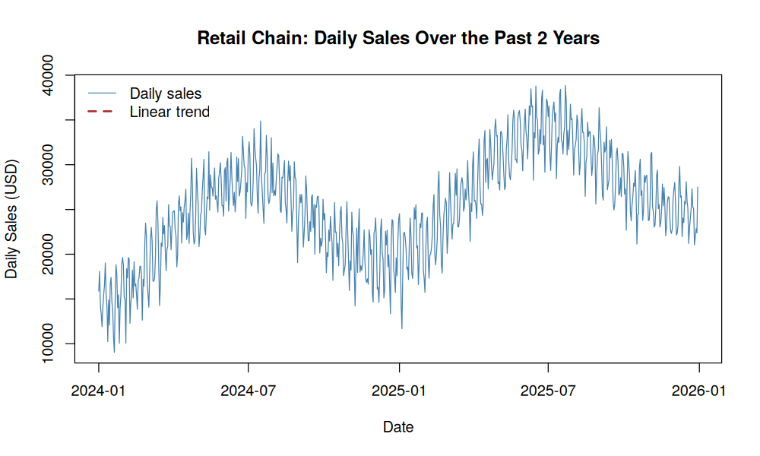

IoT Data Center — Hourly Server Temperature Monitoring

Code
"""
Task 2: IoT data-center server temperature monitoring
-------------------------------------------------------
Hourly readings over 30 days. Highlight periods exceeding the safe threshold.
"""
import numpy as np
import pandas as pd
import matplotlib.pyplot as plt

np.random.seed(202)

hours = pd.date_range("2026-07-01", periods=24 * 30, freq="h")
n = len(hours)
t = np.arange(n)

baseline = 42 + 4 * np.sin(2 * np.pi * t / 24 - 1.2) # daily heat cycle
drift = 0.01 * t # slow warm-up drift
noise = np.random.normal(0, 1.2, n)

# Inject three overheating incidents (cooling failures / load spikes)
spike = np.zeros(n)
for start, length, height in [(150, 6, 14), (380, 10, 18), (600, 5, 12)]:
spike[start:start + length] += height * np.hanning(length)

temperature = baseline + drift + noise + spike

df = pd.DataFrame({"timestamp": hours, "temp_c": temperature})

SAFE_THRESHOLD = 55.0
df["over_limit"] = df["temp_c"] > SAFE_THRESHOLD

fig, ax = plt.subplots(figsize=(10, 6))
ax.plot(df["timestamp"], df["temp_c"], color="steelblue", linewidth=1, label="Temperature")
ax.axhline(SAFE_THRESHOLD, color="firebrick", linestyle="--", linewidth=1.5,
label=f"Safe threshold ({SAFE_THRESHOLD:.0f}°C)")
ax.fill_between(df["timestamp"], df["temp_c"], SAFE_THRESHOLD,
where=df["over_limit"], color="red", alpha=0.35,
interpolate=True, label="Overheating period")

ax.set_xlabel("Time")
ax.set_ylabel("Server Temperature (°C)")
ax.set_title("Data Center: Hourly Server Temperature (30 Days)")
ax.legend(loc="upper left")
fig.autofmt_xdate()
plt.tight_layout()
plt.savefig("imgs/task2_server_temp.png", dpi=120)
plt.close()

n_over = df["over_limit"].sum()
pct_over = 100 * n_over / n
print(f"Hours above safe threshold ({SAFE_THRESHOLD}C): {n_over} of {n} ({pct_over:.1f}%)")
print(f"Max temperature recorded: {df['temp_c'].max():.1f} C at {df.loc[df['temp_c'].idxmax(),'timestamp']}")

# Identify contiguous overheating windows
over = df["over_limit"].values
windows = []
i = 0
while i < n:
if over[i]:
j = i
while j < n and over[j]:
j += 1
windows.append((df["timestamp"].iloc[i], df["timestamp"].iloc[j-1]))
i = j
else:
i += 1

print("Overheating windows detected:")
for w in windows:
print(f" {w[0]} -> {w[1]}")

Output
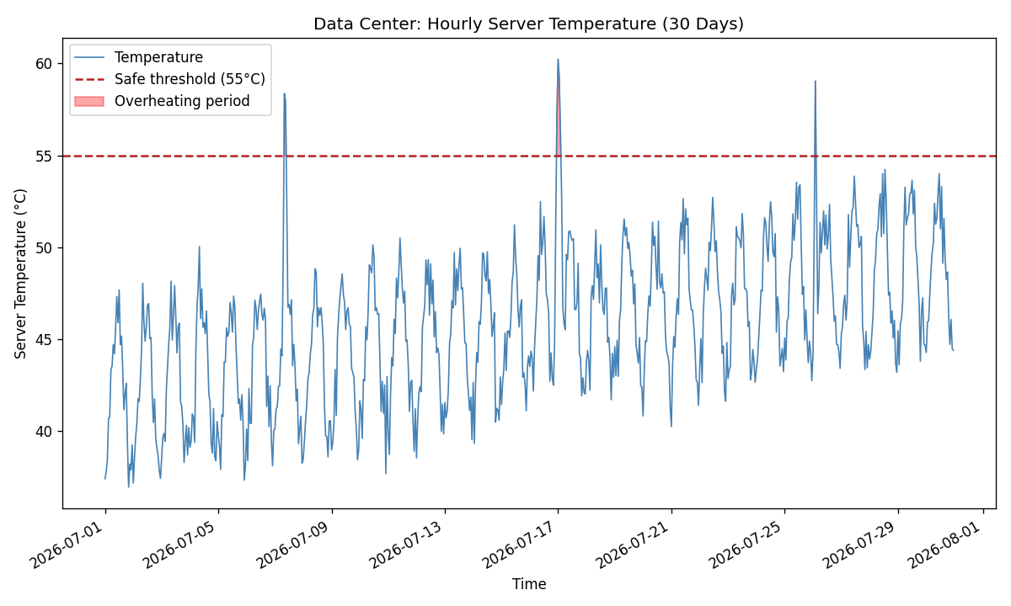

3. Hedge Fund — Comparing Three Competing Tech Stocks

Code
# Task 3: Compare daily closing prices of three competing tech stocks
# ---------------------------------------------------------------------

set.seed(303)

n_days <- 500
dates <- seq(as.Date("2024-06-01"), by = "day", length.out = n_days)

# Simulate three stocks with geometric-random-walk-like returns,
# each with a different drift (growth) and volatility (steadiness)
simulate_stock <- function(start_price, mu, sigma) {
ret <- rnorm(n_days, mean = mu, sd = sigma)
start_price * cumprod(1 + ret)
}

stockA <- simulate_stock(150, mu = 0.0009, sigma = 0.014) # TechCorp - steady grower
stockB <- simulate_stock(120, mu = 0.0011, sigma = 0.026) # InnovateX - faster but choppier
stockC <- simulate_stock(200, mu = 0.0005, sigma = 0.020) # DataSoft - modest, mid volatility

prices <- data.frame(date = dates, TechCorp = stockA, InnovateX = stockB, DataSoft = stockC)

png("imgs/task3_stocks.png", width = 1000, height = 600, res = 120)
plot(prices$date, prices$TechCorp, type = "l", col = "steelblue", lwd = 1.5,
ylim = range(prices[, -1]),
xlab = "Date", ylab = "Closing Price (USD)",
main = "Daily Closing Prices: Three Competing Tech Stocks")
lines(prices$date, prices$InnovateX, col = "firebrick", lwd = 1.5)
lines(prices$date, prices$DataSoft, col = "darkgreen", lwd = 1.5)
legend("topleft", legend = c("TechCorp", "InnovateX", "DataSoft"),
col = c("steelblue", "firebrick", "darkgreen"), lwd = 1.5, bty = "n")
dev.off()

# Volatility comparison via daily returns
rets <- data.frame(
TechCorp = diff(stockA) / head(stockA, -1),
InnovateX = diff(stockB) / head(stockB, -1),
DataSoft = diff(stockC) / head(stockC, -1)
)

vol <- sapply(rets, sd)
cagr <- sapply(list(TechCorp = stockA, InnovateX = stockB, DataSoft = stockC),
function(s) (tail(s, 1) / head(s, 1))^(365 / n_days) - 1)

cat("Daily return volatility (SD):\n"); print(round(vol, 5))
cat("\nAnnualized growth rate (CAGR):\n"); print(round(cagr * 100, 2))
cat(sprintf("\nLeast volatile stock: %s\n", names(which.min(vol))))

Output
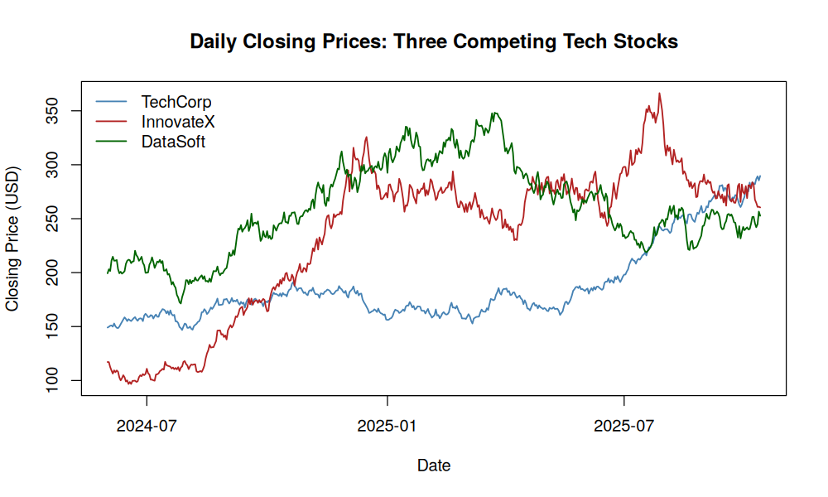

4. City Energy Board — Monthly Electricity Consumption by Neighborhood

Code
"""
Task 4: Monthly electricity consumption across four neighborhoods
--------------------------------------------------------------------
"""
import numpy as np
import pandas as pd
import matplotlib.pyplot as plt

np.random.seed(404)

months = pd.date_range("2023-01-01", periods=36, freq="MS")
t = np.arange(len(months))

def seasonal(base, amp, trend, noise_sd, phase=0):
return (base + trend * t
+ amp * np.sin(2 * np.pi * t / 12 - phase)
+ np.random.normal(0, noise_sd, len(t)))

riverside = seasonal(base=4200, amp=800, trend=3, noise_sd=120) # smooth, predictable
oakdale = seasonal(base=3600, amp=600, trend=5, noise_sd=150) # steady growth
midtown = seasonal(base=5000, amp=500, trend=-2, noise_sd=140) # stable, slight decline
pinehill = seasonal(base=3800, amp=900, trend=1, noise_sd=520, phase=0.6) # erratic: high noise

df = pd.DataFrame({
"month": months,
"Riverside": riverside,
"Oakdale": oakdale,
"Midtown": midtown,
"Pinehill": pinehill,
})

fig, ax = plt.subplots(figsize=(10, 6))
for col, color in zip(["Riverside", "Oakdale", "Midtown", "Pinehill"],
["steelblue", "darkgreen", "firebrick", "darkorange"]):
ax.plot(df["month"], df[col], marker="o", markersize=3, linewidth=1.3, label=col, color=color)

ax.set_xlabel("Month")
ax.set_ylabel("Electricity Consumption (kWh, thousands)")
ax.set_title("Monthly Electricity Consumption by Neighborhood")
ax.legend()
fig.autofmt_xdate()
plt.tight_layout()
plt.savefig("imgs/task4_electricity.png", dpi=120)
plt.close()

# "Erratic" = high variability relative to its own trend (residual noise), use CV of
# month-to-month percentage changes as an erraticism measure
summary = {}
for col in ["Riverside", "Oakdale", "Midtown", "Pinehill"]:
pct_change = df[col].pct_change().dropna()
summary[col] = {
"mean": df[col].mean(),
"std": df[col].std(),
"cv_pct": 100 * df[col].std() / df[col].mean(),
"mom_volatility": pct_change.std() * 100,
}

summary_df = pd.DataFrame(summary).T
print(summary_df.round(2))
most_erratic = summary_df["mom_volatility"].idxmax()
print(f"\nMost erratic neighborhood (highest month-over-month volatility): {most_erratic}")

Output
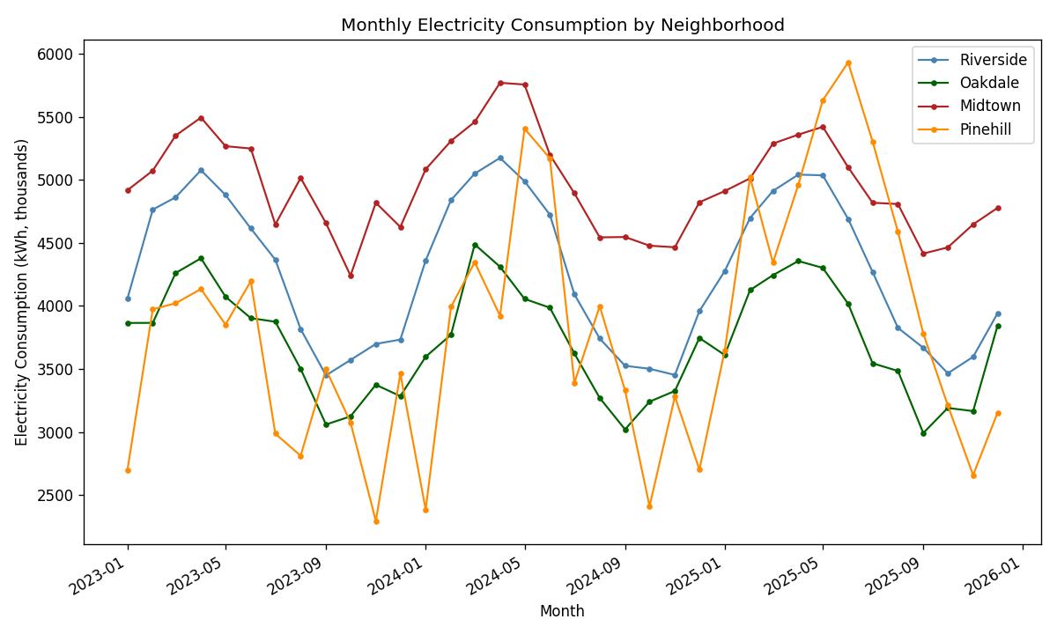

5. Pharmaceutical Trial — Dose-Response Curve for a New Drug

Code
# Task 5: Dose-response curve for a new drug (trial data)
# -----------------------------------------------------------

set.seed(505)

dose <- rep(c(0, 5, 10, 20, 40, 80, 160, 320), each = 6) # mg, 6 patients per dose

# True underlying relationship: Emax (sigmoidal) model
# response = Emax * dose^h / (ED50^h + dose^h)
Emax_true <- 95
ED50_true <- 35
h_true <- 1.3

mean_resp <- Emax_true * dose^h_true / (ED50_true^h_true + dose^h_true)
response <- pmin(100, pmax(0, mean_resp + rnorm(length(dose), 0, 5)))

trial <- data.frame(dose, response)

# Fit an Emax (sigmoidal Hill) nonlinear model
fit <- nls(response ~ Emax * dose^h / (ED50^h + dose^h),
data = trial,
start = list(Emax = 90, ED50 = 30, h = 1))

co <- coef(fit)
cat("Fitted Emax model parameters:\n"); print(round(co, 2))

# Predict a smooth curve
dose_seq <- seq(0, 320, length.out = 300)
pred <- predict(fit, newdata = data.frame(dose = dose_seq))

# Estimate the "plateau" dose: where response reaches 90% of Emax
target <- 0.9 * co["Emax"]
plateau_dose <- dose_seq[which(pred >= target)[1]]
cat(sprintf("\nDose at which response reaches 90%% of max effect (plateau onset): %.1f mg\n", plateau_dose))
cat(sprintf("ED50 (dose for half-maximal response): %.1f mg\n", co["ED50"]))

png("imgs/task5_dose_response.png", width = 1000, height = 600, res = 120)
plot(jitter(trial$dose, amount = 3), trial$response, pch = 16, col = adjustcolor("steelblue", 0.5),
xlab = "Dose (mg)", ylab = "Patient Response (%)",
main = "Dose-Response Curve: New Drug Trial")
lines(dose_seq, pred, col = "firebrick", lwd = 2)
abline(v = plateau_dose, col = "darkgreen", lty = 2, lwd = 2)
abline(h = target, col = "darkgreen", lty = 3)
legend("bottomright",
legend = c("Patient data", "Fitted Emax curve",
sprintf("Plateau onset (~%.0f mg)", plateau_dose)),
col = c("steelblue", "firebrick", "darkgreen"),
pch = c(16, NA, NA), lty = c(NA, 1, 2), lwd = c(NA, 2, 2), bty = "n")
dev.off()

Output
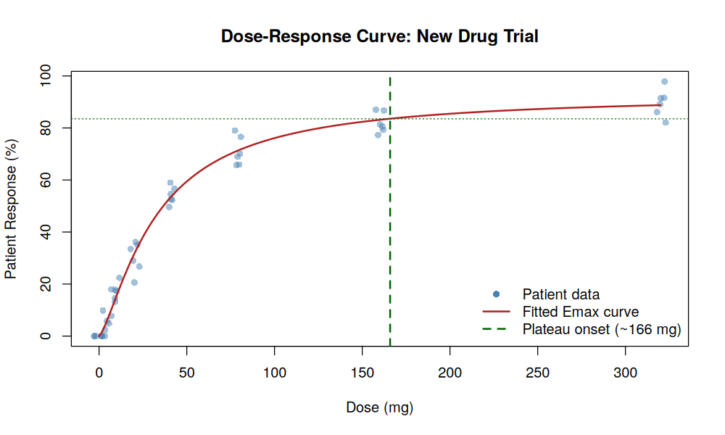

6. Agricultural Research — Fertilizer Dose vs. Crop Yield

Code
"""
Task 6: Fertilizer concentration vs crop yield (dose-response, with over-application penalty)
------------------------------------------------------------------------------------------------
"""
import numpy as np
import pandas as pd
import matplotlib.pyplot as plt
from scipy.optimize import curve_fit

np.random.seed(606)

fert_levels = np.array([0, 20, 40, 60, 80, 100, 120, 150, 180, 220, 260, 300])
reps = 5
fert = np.repeat(fert_levels, reps)

# True relationship: yield rises then falls off at high concentration (over-fertilization
# causes salt stress / nutrient burn) -- a quadratic-plateau style response
def true_yield(x):
return 20 + 0.55 * x - 0.0013 * x**2

noise = np.random.normal(0, 3.5, len(fert))
yield_t_ha = np.clip(true_yield(fert) + noise, 0, None)

df = pd.DataFrame({"fertilizer_kg_ha": fert, "yield_t_ha": yield_t_ha})

# Fit a quadratic model: yield = a + b*x + c*x^2
def quad(x, a, b, c):
return a + b * x + c * x**2

popt, _ = curve_fit(quad, df["fertilizer_kg_ha"], df["yield_t_ha"])
a, b, c = popt
x_seq = np.linspace(0, 300, 400)
y_pred = quad(x_seq, *popt)

optimal_dose = -b / (2 * c) # vertex of the parabola (max yield)
max_yield = quad(optimal_dose, *popt)

# "Safe/recommended range": within 95% of peak yield, avoiding waste beyond that
near_peak = x_seq[y_pred >= 0.95 * max_yield]
lower_bound, upper_bound = near_peak.min(), near_peak.max()

print(f"Fitted model: yield = {a:.2f} + {b:.4f}*x + {c:.6f}*x^2")
print(f"Estimated optimal fertilizer dose (peak yield): {optimal_dose:.0f} kg/ha, "
f"predicted yield {max_yield:.1f} t/ha")
print(f"Recommended dosage range (>=95% of peak yield, minimizing waste): "
f"{lower_bound:.0f}-{upper_bound:.0f} kg/ha")

fig, ax = plt.subplots(figsize=(10, 6))
ax.scatter(df["fertilizer_kg_ha"], df["yield_t_ha"], color="steelblue", alpha=0.6, label="Trial plots")
ax.plot(x_seq, y_pred, color="firebrick", linewidth=2, label="Fitted dose-response curve")
ax.axvspan(lower_bound, upper_bound, color="green", alpha=0.15, label="Recommended dose range")
ax.axvline(optimal_dose, color="darkgreen", linestyle="--", linewidth=1.5,
label=f"Peak yield dose (~{optimal_dose:.0f} kg/ha)")

ax.set_xlabel("Fertilizer Applied (kg/ha)")
ax.set_ylabel("Crop Yield (t/ha)")
ax.set_title("Fertilizer Dose vs Crop Yield")
ax.legend()
plt.tight_layout()
plt.savefig("imgs/task6_fertilizer.png", dpi=120)
plt.close()

Output
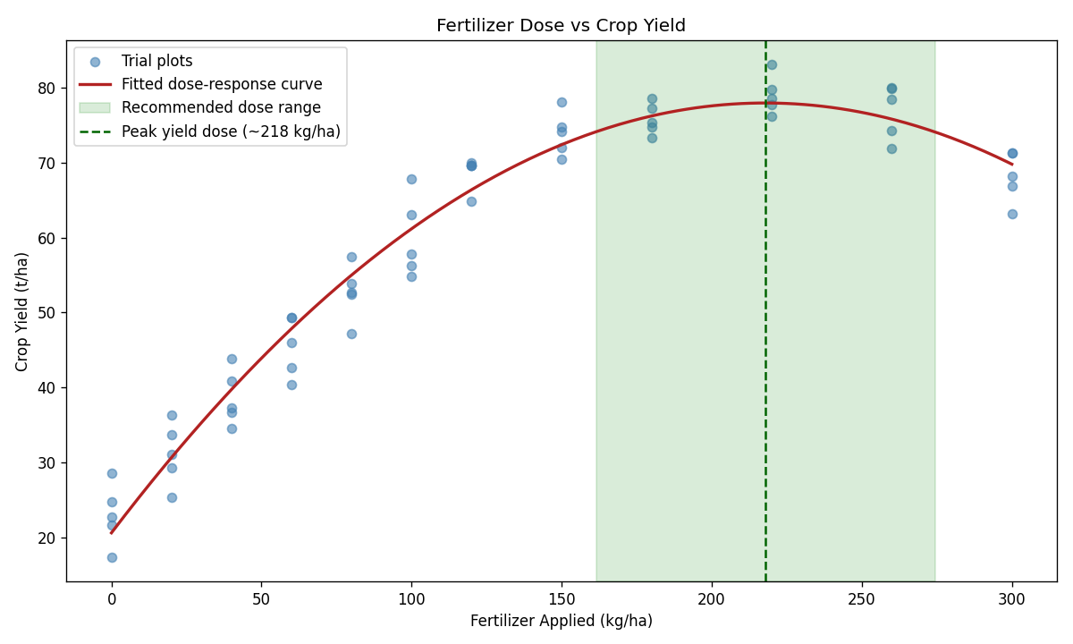
7. Airline Revenue — STL Decomposition of Monthly Ticket Sales
An airline's revenue team suspects that ticket sales follow a strong seasonal pattern tied to holidays, but a slow underlying decline is being masked by this seasonality.
Language: R

Code
# Task 7: STL decomposition of monthly airline ticket sales
# --------------------------------------------------------------

set.seed(707)

n_months <- 96 # 8 years of monthly data
t <- 1:n_months

# Underlying slow decline masked by strong holiday seasonality
trend_true <- 100000 - 250 * t
seasonal_true <- 18000 * sin(2 * pi * t / 12 + 0.6) + 9000 * cos(2 * pi * t / 12 * 2)
noise <- rnorm(n_months, 0, 2500)

sales <- trend_true + seasonal_true + noise

ticket_sales <- ts(sales, start = c(2018, 1), frequency = 12)

decomp <- stl(ticket_sales, s.window = "periodic")

png("imgs/task7_stl_airline.png", width = 1000, height = 750, res = 120)
plot(decomp, main = "STL Decomposition: Monthly Airline Ticket Sales")
dev.off()

comp <- decomp$time.series
trend_start <- as.numeric(comp[1, "trend"])
trend_end <- as.numeric(comp[n_months, "trend"])
cat(sprintf("Trend component: start = %.0f, end = %.0f, net change = %.0f (%.1f%%)\n",
trend_start, trend_end, trend_end - trend_start,
100 * (trend_end - trend_start) / trend_start))
cat(sprintf("Seasonal amplitude (range): %.0f\n", diff(range(comp[, "seasonal"]))))
cat(sprintf("Residual SD: %.0f\n", sd(comp[, "remainder"])))

Output
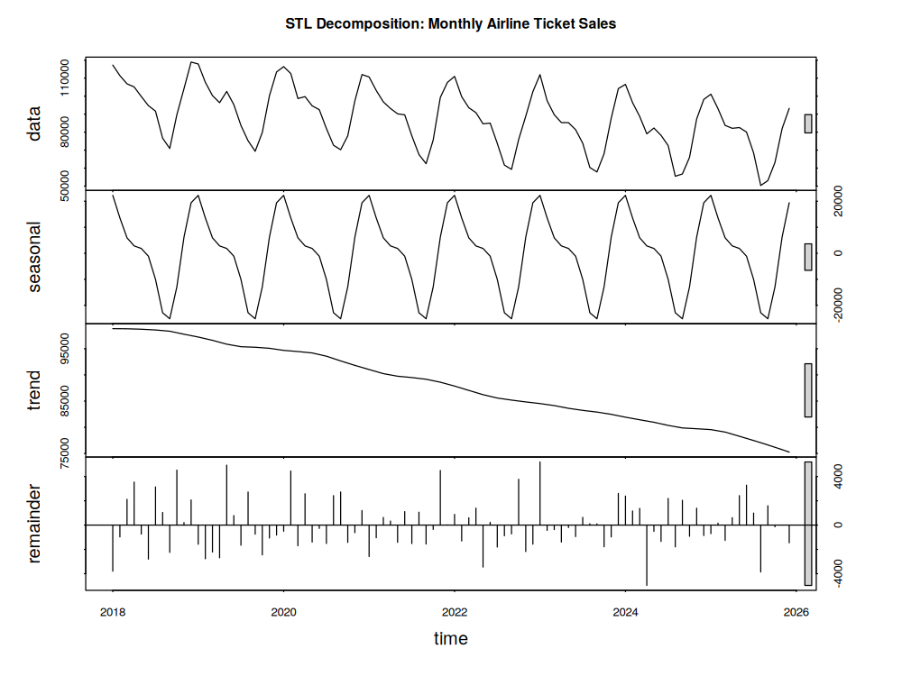

8. Streaming Platform — STL Decomposition of Weekly Active Users

Code
"""
Task 8: STL decomposition of weekly active users for a streaming platform
------------------------------------------------------------------------------
"""
import numpy as np
import pandas as pd
import matplotlib.pyplot as plt
from statsmodels.tsa.seasonal import STL

np.random.seed(808)

n_weeks = 156 # 3 years of weekly data
weeks = pd.date_range("2023-01-02", periods=n_weeks, freq="W-MON")
t = np.arange(n_weeks)

# Real underlying trend: users grew, then recently plateaued/slightly declined
trend_true = 5_000_000 + 40_000 * t - 60 * t**2
trend_true = np.clip(trend_true, 3_000_000, None)

# Strong seasonal viewing pattern (summer dip, winter/holiday peak), period ~52 weeks
seasonal_true = 350_000 * np.sin(2 * np.pi * t / 52 + 2.5)

noise = np.random.normal(0, 60_000, n_weeks)
wau = trend_true + seasonal_true + noise

df = pd.DataFrame({"week": weeks, "wau": wau}).set_index("week")
ts = df["wau"]
ts.index = pd.DatetimeIndex(ts.index).to_period("W").to_timestamp()

stl = STL(ts, period=52, robust=True)
res = stl.fit()

fig = res.plot()
fig.set_size_inches(10, 8)
fig.suptitle("STL Decomposition: Weekly Active Users (Streaming Platform)", y=1.02)
plt.tight_layout()
plt.savefig("imgs/task8_stl_streaming.png", dpi=120, bbox_inches="tight")
plt.close()

trend = res.trend
recent_change = trend.iloc[-8] - trend.iloc[-1] # last ~2 months of trend
overall_change = trend.iloc[0] - trend.iloc[-1]

print(f"Trend at series start: {trend.iloc[0]:,.0f}")
print(f"Trend at series end: {trend.iloc[-1]:,.0f}")
print(f"Trend peak: {trend.max():,.0f} (around {trend.idxmax().date()})")
print(f"Change in trend over the last 8 weeks: {recent_change:,.0f} "
f"({100*recent_change/trend.iloc[-8]:.2f}%)")
print(f"Seasonal amplitude (min to max): {res.seasonal.min():,.0f} to {res.seasonal.max():,.0f}")
print(f"Residual std dev: {res.resid.std():,.0f}")

Output
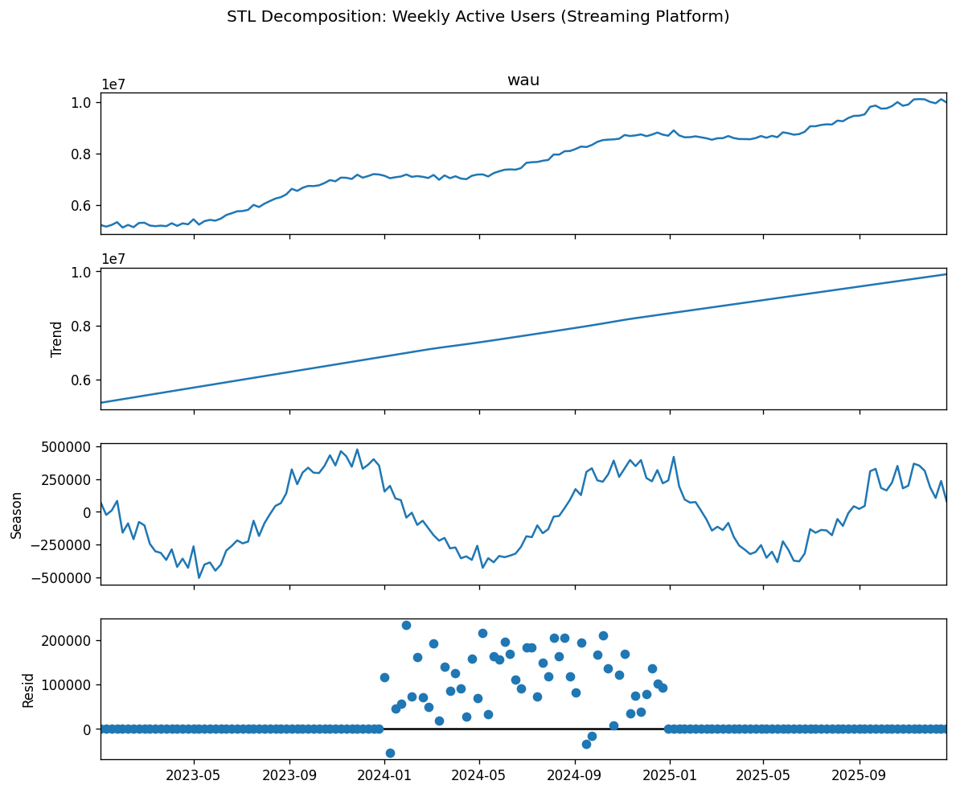

9. Stock Trading — 7-Day and 30-Day Moving Average.
Language: R

Code
# Task 9: 7-day and 30-day moving averages on a volatile stock's price
# ---------------------------------------------------------------------

set.seed(909)

n_days <- 300
dates <- seq(as.Date("2025-01-01"), by = "day", length.out = n_days)

# Simulate a volatile price series with a regime change (downtrend -> uptrend)
ret <- c(rnorm(150, mean = -0.0012, sd = 0.024),
rnorm(150, mean = 0.0018, sd = 0.024))
price <- 80 * cumprod(1 + ret)

stock <- data.frame(date = dates, price = price)

ma <- function(x, k) {
n <- length(x)
out <- rep(NA, n)
for (i in k:n) out[i] <- mean(x[(i - k + 1):i])
out
}

stock$ma7 <- ma(stock$price, 7)
stock$ma30 <- ma(stock$price, 30)

# Detect crossover points (where ma7 crosses ma30)
diff_ma <- stock$ma7 - stock$ma30
sign_change <- which(diff(sign(diff_ma)) != 0)
crossover_dates <- stock$date[sign_change + 1]

cat("Crossover dates (7-day MA crossing 30-day MA):\n")
print(crossover_dates)

png("imgs/task9_moving_avg.png", width = 1000, height = 600, res = 120)
plot(stock$date, stock$price, type = "l", col = "grey70",
xlab = "Date", ylab = "Price (USD)",
main = "Stock Price with 7-Day and 30-Day Moving Averages")
lines(stock$date, stock$ma7, col = "steelblue", lwd = 2)
lines(stock$date, stock$ma30, col = "firebrick", lwd = 2)
abline(v = crossover_dates, col = "darkgreen", lty = 3)
legend("topleft", legend = c("Raw price", "7-day MA", "30-day MA", "Crossover"),
col = c("grey70", "steelblue", "firebrick", "darkgreen"),
lty = c(1, 1, 1, 3), lwd = c(1, 2, 2, 1), bty = "n")
dev.off()

last_signal <- if (tail(diff_ma, 1) > 0) "7-day MA above 30-day MA (bullish / upward momentum)" else
"7-day MA below 30-day MA (bearish / downward momentum)"
cat("\nCurrent signal:", last_signal, "\n")

Output
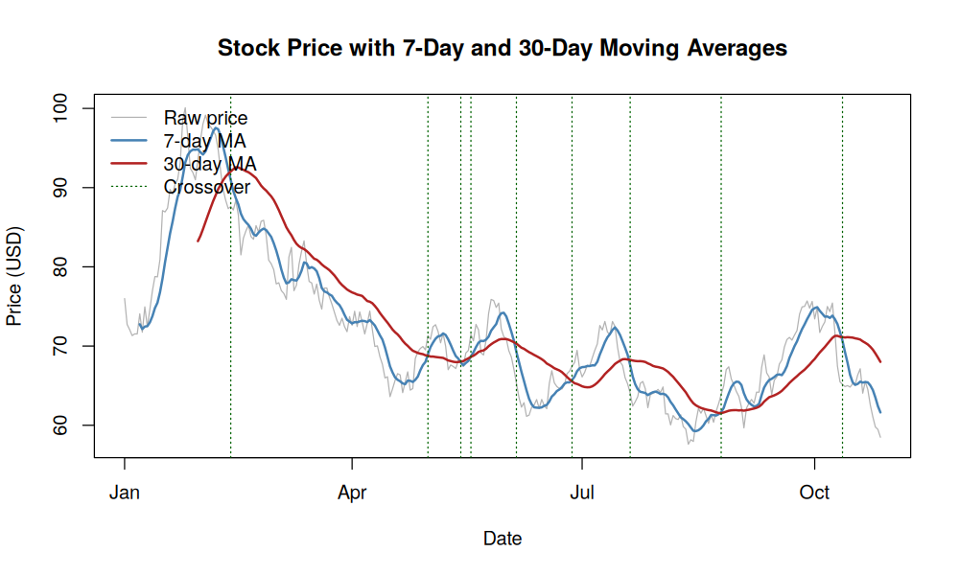
10. Economist — Detrending Quarterly GDP to Study the Business Cycle

Code
"""
Task 10: Detrend quarterly GDP to isolate business-cycle fluctuations
--------------------------------------------------------------------------
"""
import numpy as np
import pandas as pd
import matplotlib.pyplot as plt

np.random.seed(1010)

n_q = 80 # 20 years of quarterly data
quarters = pd.period_range("2005Q1", periods=n_q, freq="Q")
t = np.arange(n_q)

# Long-run growth trend (log-linear) + business-cycle waves + a recession shock + noise
log_trend = np.log(2000) + 0.006 * t
cycle = 0.02 * np.sin(2 * np.pi * t / 20) + 0.01 * np.sin(2 * np.pi * t / 7)
shock = np.zeros(n_q)
shock[58:63] -= np.array([0.01, 0.04, 0.06, 0.03, 0.01]) # a downturn (e.g., ~2020)
noise = np.random.normal(0, 0.005, n_q)

log_gdp = log_trend + cycle + shock + noise
gdp = np.exp(log_gdp)

df = pd.DataFrame({"quarter": quarters.to_timestamp(), "gdp": gdp})

# Method 1: regression-based detrending (fit linear trend to log GDP, take residuals)
X = np.vstack([np.ones(n_q), t]).T
coef, *_ = np.linalg.lstsq(X, np.log(df["gdp"]), rcond=None)
log_fit = X @ coef
df["regression_detrended_pct"] = 100 * (np.log(df["gdp"]) - log_fit)

# Method 2: first-differencing (quarter-over-quarter log growth)
df["diff_detrended_pct"] = 100 * np.log(df["gdp"]).diff()

fig, axes = plt.subplots(3, 1, figsize=(10, 10), sharex=True)

axes[0].plot(df["quarter"], df["gdp"], color="steelblue")
axes[0].set_title("Quarterly GDP (level)")
axes[0].set_ylabel("GDP (billions)")

axes[1].plot(df["quarter"], df["regression_detrended_pct"], color="firebrick")
axes[1].axhline(0, color="grey", linewidth=0.8)
axes[1].set_title("Regression-Detrended GDP (% deviation from long-run trend)")
axes[1].set_ylabel("% deviation")

axes[2].plot(df["quarter"], df["diff_detrended_pct"], color="darkgreen")
axes[2].axhline(0, color="grey", linewidth=0.8)
axes[2].set_title("Differenced GDP (quarter-over-quarter log growth, %)")
axes[2].set_ylabel("% growth")
axes[2].set_xlabel("Quarter")

fig.suptitle("Detrending Quarterly GDP to Isolate Business-Cycle Fluctuations", y=1.02)
plt.tight_layout()
plt.savefig("imgs/task10_gdp_detrend.png", dpi=120, bbox_inches="tight")
plt.close()

print(f"Long-run trend growth rate: {coef[1]*100:.3f}% per quarter "
f"(~{((1+coef[1])**4 - 1)*100:.2f}% annualized)")
print(f"Regression-detrended series: mean={df['regression_detrended_pct'].mean():.2f}%, "
f"std={df['regression_detrended_pct'].std():.2f}%, "
f"min={df['regression_detrended_pct'].min():.2f}%, "
f"max={df['regression_detrended_pct'].max():.2f}%")
worst_q = df.loc[df["regression_detrended_pct"].idxmin(), "quarter"]
print(f"Largest negative deviation from trend (business-cycle trough) around: {worst_q.date()}")
print(f"Differenced series std dev (quarter-over-quarter volatility): "
f"{df['diff_detrended_pct'].std():.2f}%")

Output
